

Practices for Secure Software Report

Table of Contents
Document Revision History 3
Client 3
Instructions 3
Developer 4
1. Algorithm Cipher 4
2. Certificate Generation 4
3. Deploy Cipher 4
4. Secure Communications 4
5. Secondary Testing 4
6. Functional Testing 4
7. Summary 4
8. Industry Standard Best Practices 4

Document Revision History

Version | Date | Author | Comments
1.0 | 02/22/26 | Erin Swinson | Final Project

Client



Developer
Erin Swinson

Algorithm Cipher
The SHA‑256 hash function as a cryptographic algorithm is perfect for generating checksums for Artemis Financial. SHA‑256 is listed in Oracle’s Java Security Standard Algorithm Names as a supported and recommended modern hash function, which ensures compatibility with the Java Security API.
SHA‑256 produces a 256‑bit fixed length output and is designed to be collision resistant, meaning it is computationally impractical for two different inputs to produce the same hash. This property makes it ideal for Artemis Financial’s file verification step, where the goal is to detect tampering or corruption during data transfer. Because SHA‑256 is a single way hash function rather than an encryption algorithm, it does not allow the original data to be reconstructed from the hash, which goes with secure by design principles.
Symmetric algorithms like AES like the ones listed in the Java Standard Algorithm Names, are used for efficient bulk encryption, while asymmetric algorithms such as RSA are used for certificate generation, digital signatures, and secure key exchange. Both categories depend on random numbers for generating keys, initialization vectors, and nonces. This concept is reinforced in the Keytool, Key and Certificate Management Tool documentation, which explains how Java’s keytool generates secure keypairs and certificate chains using strong randomness.
Earlier algorithms such as MD5, DES, and SHA‑1 were widely used but are now considered insecure due to advances in cryptanalysis. Iron Clad Java discusses avoiding outdated algorithms and adopting layered defenses. SHA‑256 and the broader SHA‑2 family are still widely trusted and are recommended by modern security standards, including OWASP guidance.

Certificate Generation
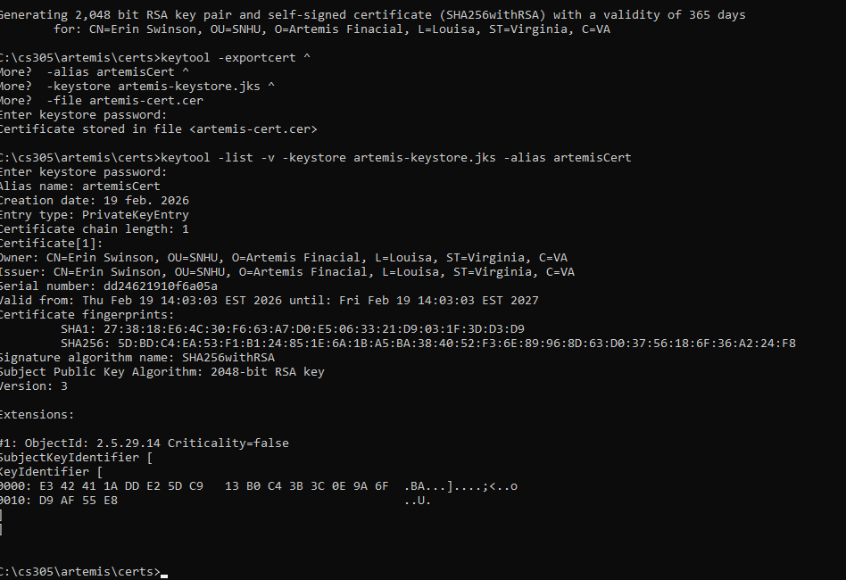
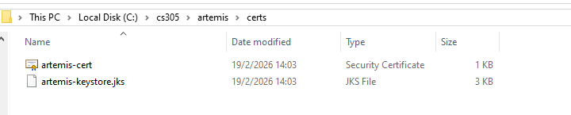

Deploy Cipher
Checksum verification.
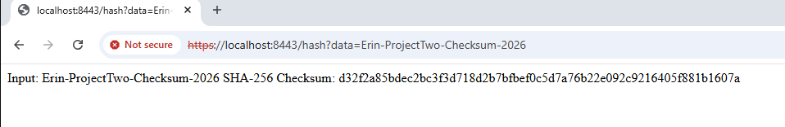

Secure Communications
Web browser that shows a secure webpage.
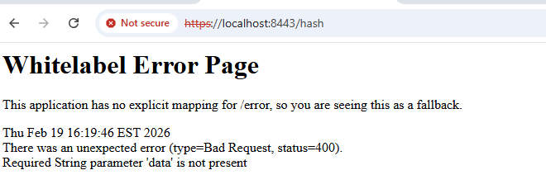

Secondary Testing
Refactored code executed without errors and the dependency-check report.
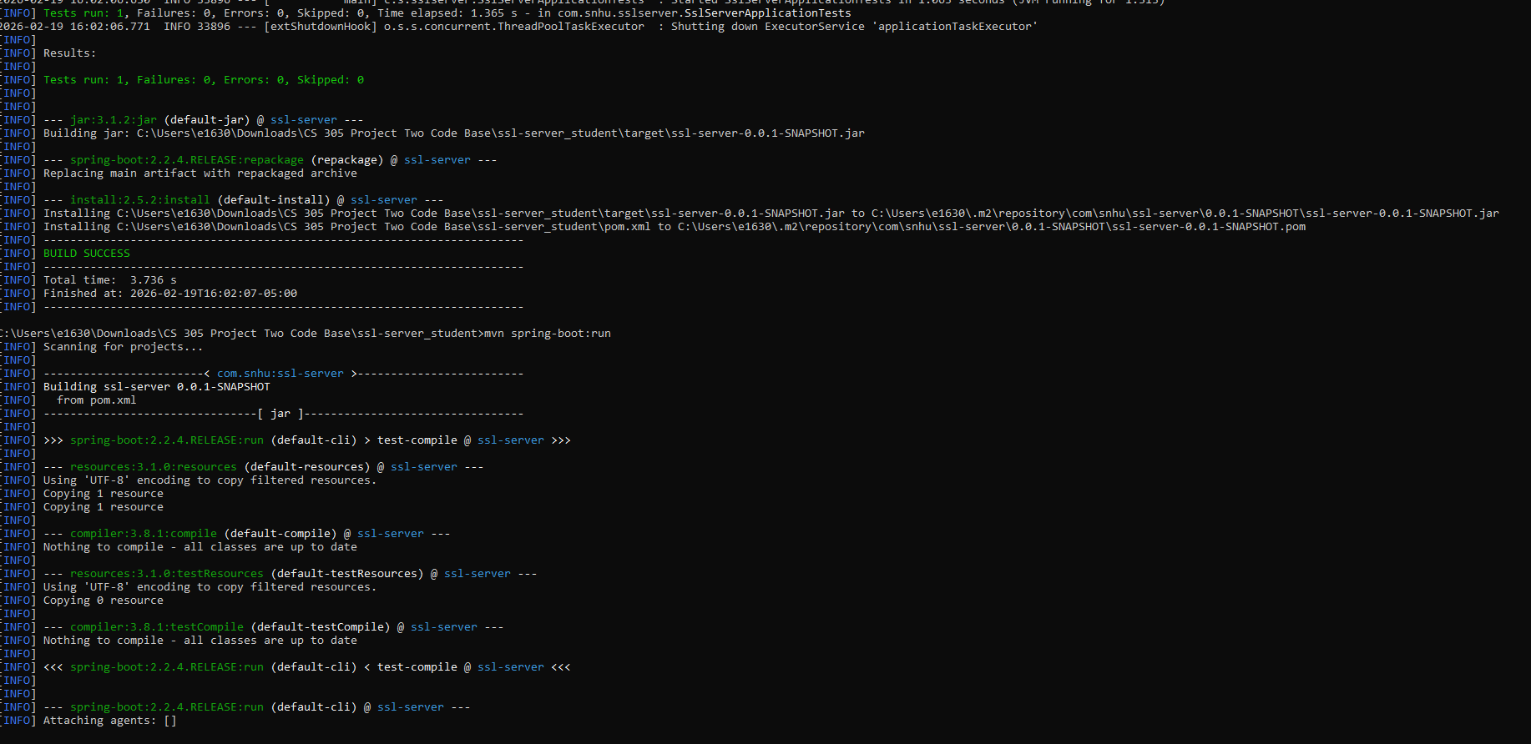
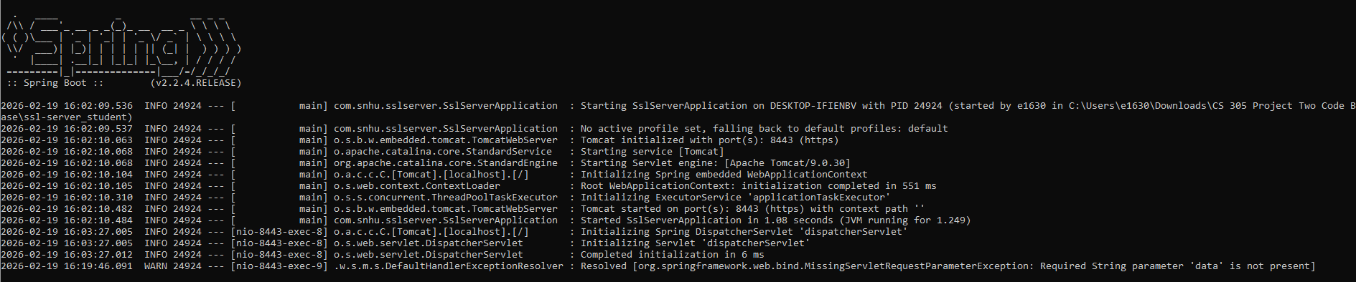
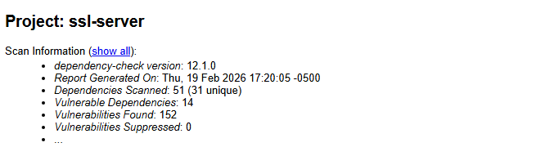
file:///C:/Users/e1630/Desktop/DC-Reports/dependency-check-report.html

Functional Testing
I conducted a comprehensive manual review of the refactored Artemis Financial codebase to identify any syntactical, logical, and security vulnerabilities.
application.properties
I verified that the TLS configuration was correctly applied, including the keystore path, password, alias, PKCS12 type, and the port change to 8443. I confirmed that the formatting followed Spring Boot conventions and that no malformed keys or spacing issues were present.
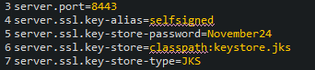
SslServerApplication.java
I reviewed the Spring Boot entry point to ensure the @SpringBootApplication annotation and main method remained correct. I also confirmed that the previous FIXME comment was resolved by implementing the checksum route in a dedicated controller.
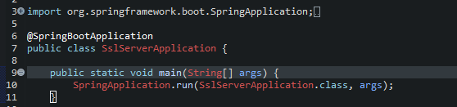
Newly created classes (ChecksumService and ChecksumController)
I verified that the imports, method signatures, and return types were correct and that the classes compiled without warnings.
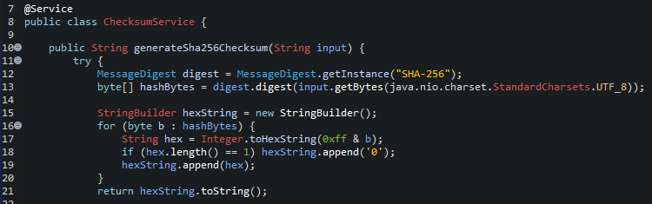
I confirmed that the application correctly bound to port 8443 and that the keystore loaded successfully at startup. I validated that the checksum endpoint returned consistent SHA‑256 hash values for static data, as noted by the previous FIXME. I ensured that the introduction of HTTPS did not break the application’s routing, controller logic, or startup sequence. I reviewed the generated SslServerApplicationTests.java file to confirm that the Spring Boot context still loaded successfully, indicating that dependency injection and application wiring were intact.
After completing the manual review, I executed the application to confirm that it still ran without errors. This verification step was especially important given the troubleshooting required earlier in the project, including resolving Java version conflicts, configuring the PKCS12 keystore, and ensuring that Spring Boot recognized the updated HTTPS settings. The successful launch of the application demonstrates that the refactoring did not break functionality and that the software continues to operate securely and as intended.

Summary
I refactored the Artemis Financial codebase to strengthen its security. I implemented secure communication by configuring the application to use HTTPS. This required generating a PKCS12 keystore, updating the Spring Boot configuration, and redirecting all traffic to port 8443. These changes eliminate plain text transmission and protect data in transit. I also added checksum generation and verification using the cryptographic hash algorithm SHA‑256.
During refactoring, I encountered several challenges that required deeper troubleshooting. Modern versions of OWASP Dependency‑Check no longer include the traditional .bat launcher, and newer releases require Java 11 or higher. Because the project itself must run on Java 8, I had to temporarily override the system Java version and run the tool using Java 17 runtime without altering the project’s build environment. I also resolved issues related to class path configuration, missing manifest attributes, and incorrect scan paths.
Once the refactoring was complete, I conducted both static and functional testing. Static testing involved running Dependency Check to identify known vulnerabilities in the project’s dependencies. Functional testing required manually reviewing the refactored code for logical, syntactical, and security issues, then executing the application to confirm that it ran without errors.

Industry Standard Best Practices
To maintain the application’s existing security, I followed best practices for implementing HTTPS using TLS. The Java Keytool documentation provided the correct procedures for generating a PKCS12 keystore and certificate, ensuring that the application used a trusted and standardized method for encryption. By configuring Spring Boot to use TLS on port 8443 and referencing the keystore through secure properties, I adhered to industry expectations for protecting data in transit. Secure communication prevents eavesdropping, tampering, and man‑in‑the‑middle attacks.
I also applied secure coding best practices when implementing checksum generation and verification. Using SHA‑256, a NIST‑approved hashing algorithm referenced in the Java Security Standard Cipher Names, I made sure that the application could detect unauthorized modifications to transmitted data.
I used OWASP Dependency‑Check to identify known vulnerabilities in third‑party libraries. This tool is widely recognized for static analysis and vulnerability management. Running the scan required troubleshooting several issues, including Java version conflicts, missing manifest attributes, and classpath errors. By resolving these problems and ultimately running the tool with a Java 17 runtime, I made sure that the vulnerability assessment was performed correctly and that the application complied with modern security testing protocols.
Applying these secure coding practices reduces the likelihood of data breaches, protects customer trust, and ensures regulatory compliance. Implementing encryption, integrity verification, and dependency scanning helps prevent costly security incidents and demonstrates due diligence in safeguarding sensitive financial data.

Resources

Oracle. (n.d.). Java security standard algorithm names. Oracle Documentation. https://docs.oracle.com/en/java/javase/17/security/oracle-providers.html

Oracle. (n.d.). Keytool: key and certificate management tool. Oracle Documentation. https://docs.oracle.com/en/java/javase/17/docs/specs/man/keytool.html

OWASP Foundation. (2024). OWASP Dependency‑Check: Software composition analysis tool. https://owasp.org/www-project-dependency-check/

